**EXPERIMENT 02**

**Implementation of a Circuit from Given Expressions**

**Objective:**

To implement a circuit from given expression, make its truth table, find its minterms. Now Implement the circuit from the minterms again and verify the results with the initial given expression.

# F=X+Ẋ.Y

**Equipment /Tool:**

Trainer, 74LS32 (OR), 74LS08 (AND), 74LS04 (NOT).

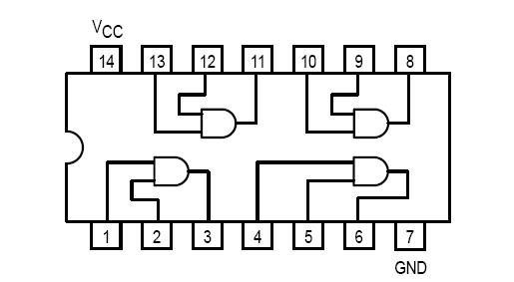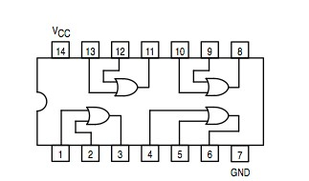

**Figure 2.** OR Gate IC 7432

**Figure 1.** AND Gate 7408

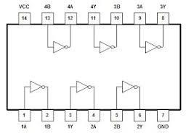

**Figure 3.** NOT Gate IC 7404

**Procedure:**

From the Expression given make the circuit on the trainer using ICs mentioned and fill in the truth table.

|  |  |  |  |  |
| --- | --- | --- | --- | --- |
| X | Y | 𝑋̅ | 𝑋̅. 𝑌 | F |
|  |  |  |  |  |
|  |  |  |  |  |
|  |  |  |  |  |
|  |  |  |  |  |

Now find the minterms of this expression and write it on the following blank

**F= .**

Implement the above expression on the trainer and fill the following table:

|  |  |  |
| --- | --- | --- |
| **X** | **Y** | **F** |
| 0 | 0 |  |
| 0 | 1 |  |
| 1 | 0 |  |
| 1 | 1 |  |

Now verify the results of both the tables. Are they both the same or not? And why?